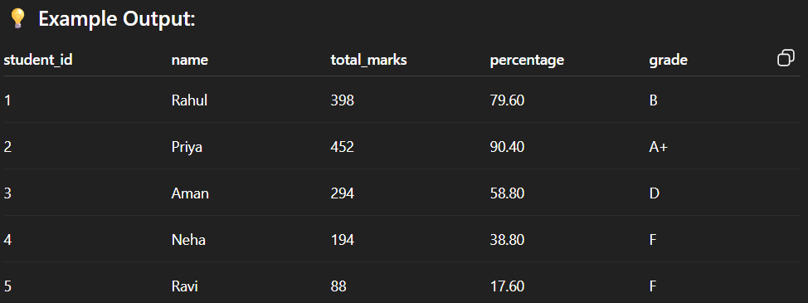

🡺  
**MySQL-based Marksheet system**

**✅ Features:**

1. Total subject marks calculate hote hain
2. Percentage nikala jaata hai
3. Grade assign hota hai condition ke basis pe

**Step 1: Database Create Karna**

CREATE DATABASE student_marksheet;

**Step 2: Table Create Karna**

USE student_marksheet;

CREATE TABLE marksheet (

student_id INT PRIMARY KEY AUTO_INCREMENT,

name VARCHAR(100),

subject1 INT,

subject2 INT,

subject3 INT,

subject4 INT,

subject5 INT

);

**Step 3: Sample Data Insert Karna**

INSERT INTO marksheet (name, subject1, subject2, subject3, subject4, subject5) VALUES

('Rahul', 80, 75, 68, 90, 85),

('Priya', 95, 88, 92, 86, 91),

('Aman', 55, 60, 58, 62, 59),

('Neha', 35, 40, 38, 42, 39),

('Ravi', 20, 18, 25, 15, 10);

**Step 4: Simple Total Marks, Percentage aur Grade**

SELECT

student_id,

name,

subject1 + subject2 + subject3 + subject4 + subject5 AS total_marks,

ROUND((subject1 + subject2 + subject3 + subject4 + subject5)/5, 2) AS percentage,

CASE

WHEN (subject1 + subject2 + subject3 + subject4 + subject5)/5 >= 90 THEN 'A+'

WHEN (subject1 + subject2 + subject3 + subject4 + subject5)/5 >= 80 THEN 'A'

WHEN (subject1 + subject2 + subject3 + subject4 + subject5)/5 >= 70 THEN 'B'

WHEN (subject1 + subject2 + subject3 + subject4 + subject5)/5 >= 60 THEN 'C'

WHEN (subject1 + subject2 + subject3 + subject4 + subject5)/5 >= 50 THEN 'D'

ELSE 'F'

END AS grade

FROM marksheet;

**💡 Example Output:**

| **student_id** | **name** | **total_marks** | **percentage** | **grade** |
| --- | --- | --- | --- | --- |
| 1 | Rahul | 398 | 79.60 | B |
| 2 | Priya | 452 | 90.40 | A+ |
| 3 | Aman | 294 | 58.80 | D |
| 4 | Neha | 194 | 38.80 | F |
| 5 | Ravi | 88 | 17.60 | F |

🡺: ROUND((subject1 + subject2 + subject3 + subject4 + subject5)/5, 2) AS percentage,

• **subject1 + subject2 + ... + subject5**  
→ Student ke 5 subjects ke marks ka t+otal nikaal raha hai.

• **/5**  
→ Total ko 5 se divide kar raha hai, jisse **average marks** yaani **percentage** milta hai (kyunki total 5 subjects hain).

• **ROUND(..., 2)**  
→ Percentage ko **2 decimal places** tak round kar raha hai.  
Jaise agar result 78.666666 ho toh 78.67 ban jaayega.

• **AS percentage**  
→ Is result ka naam percentage diya ja raha hai (yeh SQL ka alias hota hai).

TASK 🡪 2

| **ID** | **Name** | **Hindi** | **English** | **Math** | **Science** | **SST** | **Total** | **%** | **Grade** |
| --- | --- | --- | --- | --- | --- | --- | --- | --- | --- |
| 1 | Rahul | 80 | 75 | 68 | 90 | 85 | 398 | 79.60 | B |
| 2 | Priya | 95 | 88 | 92 | 86 | 91 | 452 | 90.40 | A+ |

Sol 🡪

**🎯 Objective:**

SQL query se hi:

* Subject-wise marks dikhana
* Total marks nikalna
* Percentage nikalna
* Grade assign karna

**✅ Step 1: Database Create**

CREATE DATABASE student_marksheet;

USE student_marksheet;

**✅ Step 2: Table Create**

CREATE TABLE marksheet (

student_id INT PRIMARY KEY AUTO_INCREMENT,

name VARCHAR(100),

subject1 INT, -- Hindi

subject2 INT, -- English

subject3 INT, -- Math

subject4 INT, -- Science

subject5 INT -- SST

);

**✅ Step 3: Data Insert**

INSERT INTO marksheet (name, subject1, subject2, subject3, subject4, subject5) VALUES

('Rahul', 80, 75, 68, 90, 85),

('Priya', 95, 88, 92, 86, 91),

('Aman', 55, 60, 58, 62, 59),

('Neha', 35, 40, 38, 42, 39),

('Ravi', 20, 18, 25, 15, 10);

**✅ Step 4: Final SQL Query — Marksheet Display**

SELECT

student_id,

name,

subject1 AS Hindi,

subject2 AS English,

subject3 AS Math,

subject4 AS Science,

subject5 AS SST,

(subject1 + subject2 + subject3 + subject4 + subject5) AS total_marks,

ROUND((subject1 + subject2 + subject3 + subject4 + subject5) / 5, 2) AS percentage,

CASE

WHEN (subject1 + subject2 + subject3 + subject4 + subject5) / 5 >= 90 THEN 'A+'

WHEN (subject1 + subject2 + subject3 + subject4 + subject5) / 5 >= 80 THEN 'A'

WHEN (subject1 + subject2 + subject3 + subject4 + subject5) / 5 >= 70 THEN 'B'

WHEN (subject1 + subject2 + subject3 + subject4 + subject5) / 5 >= 60 THEN 'C'

WHEN (subject1 + subject2 + subject3 + subject4 + subject5) / 5 >= 50 THEN 'D'

ELSE 'F'

END AS grade

FROM marksheet;

**📋 Output Format:**

| **ID** | **Name** | **Hindi** | **English** | **Math** | **Science** | **SST** | **Total** | **%** | **Grade** |
| --- | --- | --- | --- | --- | --- | --- | --- | --- | --- |
| 1 | Rahul | 80 | 75 | 68 | 90 | 85 | 398 | 79.60 | B |
| 2 | Priya | 95 | 88 | 92 | 86 | 91 | 452 | 90.40 | A+ |

🡺TASK 3

**🎓 SQL Assignment:** Marksheet Data Analysis

**📋 Instructions for Students:**

You are given the **marksheet table** of 10 students. Each student has marks in 5 subjects:

* **Hindi**
* **English**
* **Math**
* **Science**
* **SST**

The table structure is as follows:

| **student_id** | **name** | **subject1** | **subject2** | **subject3** | **subject4** | **subject5** |
| --- | --- | --- | --- | --- | --- | --- |
| (Auto ID) | Name | Hindi | English | Math | Science | SST |

Q :

DATA :

('Rahul', 80, 75, 68, 90, 85),

('Priya', 95, 88, 92, 86, 91),

('Aman', 55, 60, 58, 62, 59),

('Neha', 35, 40, 38, 42, 39),

('Ravi', 20, 18, 25, 15, 10),

('Simran', 88, 84, 90, 87, 89),

('Karan', 65, 70, 68, 60, 72),

('Anjali', 78, 80, 82, 79, 85),

('Vikas', 45, 50, 48, 52, 49),

('Divya', 91, 89, 93, 88, 90)

Question :>

• Display each student’s total marks.

• Calculate and display the percentage of each student.

• Assign grades based on percentage using CASE statement.

• Find the **topper** of the class.

• Find how many students **failed** (i.e., percentage less than 50%).

• Display **subject-wise marks**, total, percentage, and grade together.

• Count how many students got **‘A’ grade or above**.

• Sort the marksheet in **descending order of total marks**.